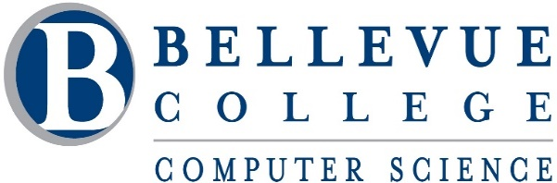

**CS 481 SENIOR CAPSTONE I (3 Cr.)**

**FALL 2020**

**Supervisors:** Alfred Nehme **|** Fatma Cemile Serce| Sara Farag | Zhi Li

Capstone project is a major component of almost all undergraduate computer science curricula. The purpose of this course is for students to learn the software product development process and complete a significant computer science project as a final preparation before entering into industry. This course provides students with the opportunity to gain a number of separate but highly important technical and soft skills; surveying literature, report writing, documenting software, presenting topics, scheduling, project management, working in teams, and so on. This course is the first of three-quarter sequence capstone courses. Students will continue to develop and improve the product in Senior Capstone II and III.

**Catalog Description:** This course focuses on literature review, requirement specification, project management, and initial design and prototyping of the three-quarter long computer science project. Students work in teams and are given milestones. The course includes lectures, reading assignments, and guest speakers on development process, team working, report writing and emerging trends in computer science.

**Course Content Outline**: Software Engineering. Research Process. Literature Reviews. Report Writing. Requirements Specification. Project Management Plan. Initial Design. Prototyping. National and International Standards. Referencing Material. Avoiding Plagiarism. Team Work.

**Learning Outcomes**: After completing this class, students should be able to:

## Follow a formal software development process to complete the project

## Write a project management plan to describe the team’s management process including project milestones and timelines

## Prepare a requirements specifications document describing the expected features, constraints, interfaces and other attributes

## Write an initial design document describing of how the product is to be implemented and which tools and techniques that are needed to complete the project

## Implement at least two key features of the product

## Perform independent learning of new technologies and concepts in order to complete the project

## Work productively in a team environment communicating appropriately with all team members

* Identify key ethical and legal issues affecting computer science projects

**Course Policy:**

* Project concept topics can be proposed by the students, by the instructors, and by the external advisors. The concepts are validated and the projects receive the “green light” only after brainstorming and analysis meetings of the teams with the advisors.
* The Project Preference Form needs to be filled out as a group and to be submitted to the course coordinator (Alfred Nehme) by **9:00 AM** on Tuesday **Sept 29**. No change is allowed after the submission.
* The teams-projects and advisor assignments will be announced on Wednesday **Sept 30** at 2:30 PM (during a live meeting session).
* It is the students’ responsibilities to switch sections and register to the correct section of CS 481 (the section of your supervisor). You can do this online [here](https://forms.bellevuecollege.edu/studentcentral/schedule-adjustment-request-time-conflict-misplacement/).
* Each team consists of four students (only 1 team will have 3 students).
* All projects are guided by the course instructors, who supervise the entire project cycle, from analysis to demonstration.
* The teams of students have one year (three quarters) to develop their projects.
* Throughout the quarters, the teams report on their work through documents (deliverable) submitted to their instructors and through project presentations delivered during regular classes.
* The course instructor is not a team member or lecturer. The instructor’s role is to supervise teams on various topics, requirements, design issues, architecture, implementation, and examine and grade the deliverables.
* Deliverables:
  + Press Release FAQ (PR FAQ).
    - See file “*PR_FAQ_Template.docx*” for a template to follow.
    - See file “*PR_FAQ_Example.docx*” for an example PR FAQ for inspiration.
  + Requirements Specification Document.
  + Design Document (Architectural Design, User Interface Design).
  + Implementation and Testing.
  + Sprint Progress report.
* Presentations and Publications
  + Tech Presentation.
  + Prototype presentation at the end of the quarter.
* Participation
  + Attendance of weekly meetings
  + Attendance of guest speaker sessions
* Late submissions of any material will be penalized.
* If a student withdraws from the course, the remaining team members are responsible to complete the project.

**Grading:**

|  |  |  |
| --- | --- | --- |
|  | Documentation | 35% |
|  | Development | 40% |
|  | Project Presentation | 10% |
|  | Technical Talks | 10% |
|  | Attendance & Participation | 5% |

Your final letter grade is based on your final score based on the ranges shown in the table below:  
  
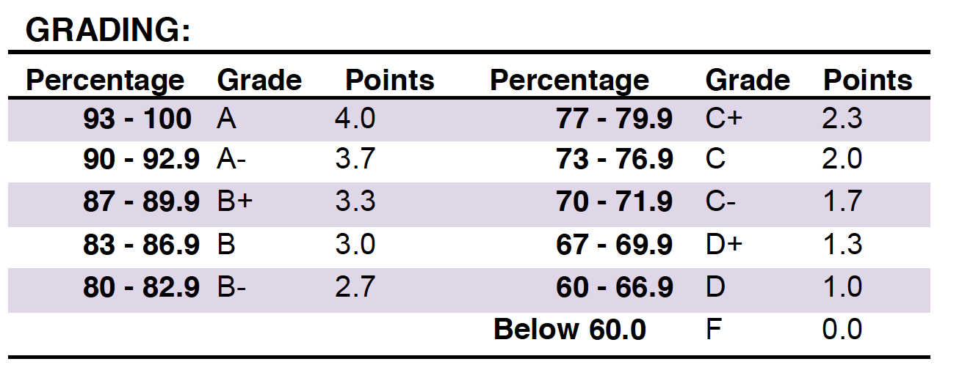

**Deliverables for Fall Quarter**

|  |  |  |  |  |  |
| --- | --- | --- | --- | --- | --- |
| **Deliverable** | **Eval. Type** | **Sprint1** Wed Sept 30 –  Tue Oct 13  Eval: Wed Oct 14 | **Sprint2** Wed Oct 14 - Tue Oct 27  Eval: Wed Oct 28 | **Sprint3** Wed Oct 28 –  Tue Nov 10  Eval: Thurs Nov 12 | **Sprint4** Thurs Nov 12 - Tue Dec 1  Eval: Wed Dec 2 |
| **Development** | **Individual** |  | Source code + demo. | Source code + demo. | Source code + demo. |
| **Documentation** | **Team** | - PR FAQ  - Sprint Progress Report  Due: Wed Oct 14 | - SRS  - Sprint Progress Report    Due: Wed Oct 28 | - SRS  - SDD  - Sprint Progress Report    Due: Thurs Nov 12 | - SRS  - SDD  - STD  Testing- log  - Sprint Progress Report  Due: Wed Dec 2 |
| **Technical Talks** | **Individual + Team** | Each group gets 15 minutes. **Wed Nov 4**: Pi Player, Global Electricity Generation, Expedia Review Trends, Road Lanes Detection, DevOps Pipeline with GitHub, Audit Now  **Wed Nov 18**: Safe Shop, Expenses Advisor, Code Reviewer, Text Input Spy, Virtual Library | | | | |
| **Final Demonstration & sprint 4 report** | **Individual + Team** | **Wednesday & Thursday Dec 2 & 3 2020, 2:30 – 5:20 PM** (TENTATIVE)  **Wednesday**: Pi Player, Global Electricity Generation, Expedia Review Trends, Road Lanes Detection, DevOps Pipeline with GitHub, Audit Now  **Thursday**: Safe Shop, Expenses Advisor, Code Reviewer, Text Input Spy, Virtual Library | | | | |

### Miscellaneous Notes

Keep backup (electronic) copies of all submitted work. Keep graded work until at least the end of the quarter.

#### Affirmation of Inclusion

Bellevue College is committed to maintaining an environment in which every member of the campus community feels welcome to participate in the life of the college, free from harassment and discrimination.

We value our different backgrounds at Bellevue College, and students, faculty, staff members, and administrators are to treat one another with dignity and respect. Affirmation of Inclusion (<https://www.bellevuecollege.edu/inclusion/>)

#### Religious Holidays

Students who expect to miss classes, examinations, or any other assignments because of their religious observance should be provided with a reasonable alternative opportunity to complete such academic responsibilities. It is the obligation of students to provide faculty with reasonable notice of the dates of religious holidays on which they will be absent, preferably at the beginning of the term. The [Request for Accommodations for Reasons of Faith or Conscience Form (Links to an external site.)](https://cm.maxient.com/reportingform.php?BellevueCollege&layout_id=30) provides more information about and the steps to request this accommodation.

Students who are absent on days of examinations or class assignments should be offered an opportunity to make up the work without penalty (if they have previously arranged to be absent), unless it can be demonstrated that a makeup opportunity would constitute an unreasonable burden on a member of the faculty. Should disagreement arise over what constitutes an unreasonable burden or any element of this policy, parties involved should consult the department chair, or Dean.

[Policy 2950 Accommodations for Reasons of Faith or Conscience (Links to an external site.)](http://www.bellevuecollege.edu/policies/id-2950p-2/) (http://www.bellevuecollege.edu/policies/id-2950p-2/).

#### Student Code of Conduct and Academic Integrity

Any act of academic dishonesty, including cheating, plagiarism (using the ideas or words of another as one’s own without crediting the source), and fabrication and inappropriate/disruptive classroom behavior are violations of the Student Code of Conduct at Bellevue College. Examples of unacceptable behavior include, but are not limited to, talking out of turn, arriving late or leaving early without a valid reason, allowing cell phones/pagers to ring, and inappropriate behavior toward the instructor or classmates. The instructor can refer any violation of the Student Code of Conduct to the Dean of Student Success for investigation. Specific student rights, responsibilities, and appeal procedures are listed in the Student Code of Conduct at: [Student Code](http://www.bellevuecollege.edu/policies/id-2050/)

When appropriate, I will use a Measure of Software Similarity (MOSS) to assess copies of code submitted for grading. Plagiarism: to steal and pass off (the ideas or words of another) as one's own, use (another's production) without crediting the source (from Merriam-Webster). Plagiarized code will be immediately assessed a zero. [Stanford link to MOSS](http://theory.stanford.edu/~aiken/moss)

## Important Links

### Academic Calendar

The Bellevue College Academic Calendar is separated into two calendars. They provide information about holidays, closures and important enrollment dates such as the finals schedule.

* [**Enrollment Calendar**](http://bellevuecollege.edu/enrollment/calendar/deadlines/)  On this calendar you will find admissions and registration dates and important dates for withdrawing and receiving tuition refunds.
* [**College Calendar .**](http://www.bellevuecollege.edu/enrollment/holidays/) This calendar gives you the year at a glance and includes college holidays, scheduled closures, quarter end and start dates, and final exam dates.

### Additional Information

#### Bellevue College E-mail and access to MyBC

All students registered for classes at Bellevue College are entitled to a network and e-mail account. Your student network account can be used to access your student e-mail, log in to computers in labs and classrooms, connect to the BC wireless network and log in to MyBC. To create your account, go to: [Create Your Account](https://www.bellevuecollege.edu/netid/CreateNewAccount.aspx)

BC offers a wide variety of computer and learning labs to enhance learning and student success. Find current campus locations for all student labs by visiting the [Computer Labs Website](http://depts.bellevuecollege.edu/helpdesk/students/computerlabs/)

#### Disability Resource Center (DRC)

The Disability Resource Center serves students with a wide array of learning challenges and disabilities. If you are a student who has a disability or learning challenge for which you have documentation or have seen someone for treatment and if you feel you may need accommodations in order to be successful in college, please contact us as soon as possible.

If you are a person who requires assistance in case of an emergency situation, such as a fire, earthquake, etc., please meet with your individual instructors to develop a safety plan within the first week of the quarter.

If you are a student with a documented autism spectrum disorder, there is an additional access program available to you. Contact asn@bellevuecollege.edu or 425.564.2764. ASN is located in the Library Media Center in D125.  [Autism Spectrum Navigators](http://www.bellevuecollege.edu/autismspectrumnavigators/)

The DRC office is located in B132 or you can call our reception desk at 425.564.2498. Deaf students can reach us by video phone at 425-440-2025 or by TTY at 425-564-4110. Please visit our website for application information into our program and other helpful links at [Disability Resource Center](http://www.bellevuecollege.edu/drc)

#### Public Safety and Emergencies

Public Safety is located in the K building and can be reached at **425-564-2400** (easy to remember because it’s the only office on campus open 24 hours a day—2400). Among other things, Public Safety serves as our Parking Permits, Lost and Found, and Emergency Notification

center. Please ensure you are signed up to receive alerts through our campus alerting system by registering at [Rave Alert Emergency Notification System](http://www.bellevuecollege.edu/alerts/?ref=footer)

If you work late and are uneasy about going to your car, Public Safety will escort you to your vehicle. To coordinate this, please phone ahead and let Public Safety know when and where you will need an escort.

Please familiarize yourself with the emergency postings by the door of every classroom and know where to go in the event of an evacuation. Your instructor will be asked if anyone might still be in the building, so check in before you do anything else. Emergency responders will search for anyone unaccounted for.

**If a major emergency occurs, please follow these two rules:**

1. **Take directions from those in charge of the response** - We all need to be working together.
2. **Do not get in your car and leave campus (unless directed to)** - Doing so will clog streets and prevent emergency vehicles from entering the scene. Instead, follow directions from those in charge.